**Activities to Build ENGAGEMENT**

**Student Learning**

Extended Day Opportunities

Parent Meetings

English Learner Activities

School Site Council

PFA

Back to School Night/Open House

Technology websites to use at home

**Social-Emotional Development and Growth**

Family Fun Night

Movie Night

PFA sponsored activities

Second Step Curriculum

College and Career Awareness Activities

**Volunteering Opportunities**

If you would like to *volunteer, participate* in, and/or *observe a classroom please let your teacher know.*

**Chino Valley Unified**

**School District**

**What is Home-School Partnerships?**

Home-School Partnerships is an agreement that parents, students and teachers develop together. It explains how parents and teachers will work together to make sure all students reach or exceed grade-level standards.

Effective compacts:

* **Link** to goals of the school's single plan for student achievement
* **Focus** on student learning skills
* **Describe** how teachers will help students develop those skills using high-quality curriculum and effective instruction in a supportive learning environment
* **Share** strategies parents can use at home
* **Explain** how teachers and parents will communicate about student progress
* **Describe** opportunities for parents to volunteer, observe, and participate in the classroom

**PARTNERSHIPS FAMILY PARTICIPATION**

**HOME-SCHOOL PARTNERSHIPS**

**for**

**STUDENT ACHIEVEMENT**

**2023-2024**

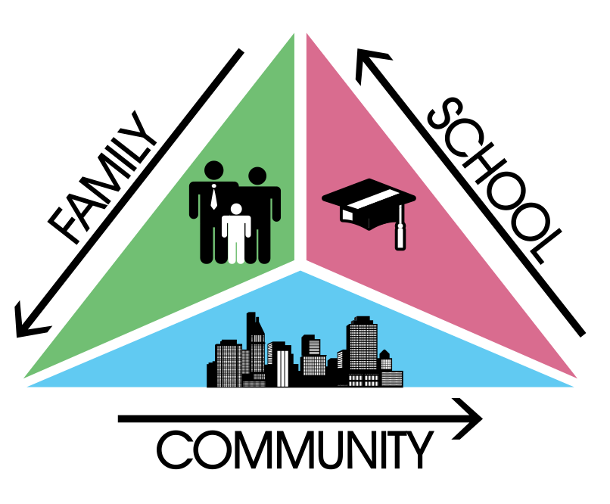

**FIRST GRADE**

***Always walk through life as if you have something new to learn and you will.***

***Vernon Howard***

Alicia Cortez Elementary

12750 Carissa Ave. Chino, CA 91710

(909) 627-9438

**Learning Compact**

**Communication about Student Learning**

Our school and families are committed to regular two-way communication about our children’s' learning. Some of the ways families and staff communicate all year are:

* **School to Home**
  + newsletters
  + school website
  + Phone Blasts
  + Parent Square
  + frequent progress monitoring
* **Home to School**
  + school agendas
  + email
  + parent-teacher meetings
  + Homework Folders
  + participate in "activities to build

engagement” (see above)

**https://www.chino.k12.ca.us/Cortez**

**DISTRICT PARENT RESOURCES**

**Family Engagement Center**

**Adult School, Room 25**

**12970 Third St. Chino, CA 91710**

***ENGLISH LEARNER PARENT ACADEMY***

***EARLY LEARNING 2 years to 4 years***

***TRANSITIONS***

***THE ART OF PARENTING***

**Parent and School Partnership Link:**

**http://www.chino.k12.ca.us/Page/8882**

**909 628-1201 ext. 5601**

**(Spanish) 909 628-1201 ext. 5602**

**At Home**

**I will provide these activities and/or supports at home to support my child's learning this year.**

**Academic Goal**

Practice speaking in complete sentences.

Practice math facts to 20.

Connect ED (ClassLink)

Focus on High Frequency Words

Practice with educational technology to support proficiency in ELA and Math. (iReady, AR, Lexia)

Ensure your child reads or is read to on a nightly basis.

**Non-Academic Goal**

Volunteer time in the classroom and communicate with teacher as needed.

Attend parent learning nights/meetings.

Make illness the only excuse for absence.

Reinforce the Cortez Four

Ensure student is well rested

**English Learner Goal**

Reinforce writing strategies learned in class at home.

Practice speaking in complete sentences.

Focus on learning High Frequency Words to support reading proficiency.

**At home, I will reinforce classroom learning by:**

Ensuring my child is at school, on time, each and every day. Check my child’s homework for accuracy, neatness and completeness.

**In the Classroom**

**In our First grade classroom, I will engage all students with a vibrant learning climate and high-quality instruction. Here are some of the student learning strategies your child will use this year.**

**GOAL 1 Academic Goal**

Write frequently across subject areas

Incorporate writing into sharing to build oral language development.

Students will participate in extra support activities that build on Foundational Skills that lead to proficiency in ELA and Math and build on computer skills; AR, iReady, Wonders and Pearson

**GOAL 2 Non-Academic Goal**

Positive behavior systems, including PBIS and Second Step instruction. Participate in monthly activities that focus on College and Career Awareness.

**GOAL 3 English Learner Goal**

Instruct to a variety of learning styles such as visual, auditory, kinesthetic, etc.

Instruct utilizing various ELD strategies such as pair sharing, pictures, anchor charts, read-aloud, etc.

30 minutes of daily Designated English Language

**District Goals - Local Control Accountability Plan (LCAP)**

All students are provided a high-quality teaching and learning environment.

Staff, parents, families, and students are connected and engaged at their school to ensure student success.

All students are prepared for college and career beyond graduation.

**School Goals**

Academic: This year 100% of grade level teams will respond with intervention and extension for at least 3 learning target(s) with Tier 1 and Tier 2 instruction, as measured by artifacts showing intervention and extension plans by the end of the 2022-2023 school year. Based on 21-22 ESA #3 data, (35.9%) of students in grades K-6 met or exceeded standards in English Language Arts and (30.3%) of students in grades K-6 met or exceeded standards in Mathematics.

Non-Academic :The overall TFI score at Alicia Cortez reflects that, as of 4/26/22, an External TFI completed at Cortez reflected 100% implementation for school-wide PBIS implementation of Tier I and 92% implementation for Tier 2. The PBIS team identified Student/Family/Community Involvement (TFI 1.11) and Student Performance Data (TFI 2.11) as the features to work on as we move forward and has developed an action plan to monitor progress toward this goal. TIER 2 training will continue in the 2022-2023 school year.

English Learner: By end of year, as a result of high quality, daily Designated ELD and Integrated ELD instruction we will see a decrease in the number of LTELs on our campus.

*Our school provides high quality curriculum and instruction in supportive and effective classroom environments to enable students to meet state academic standards. We support our students and work hard to provide a welcoming, safe school environment.*

**Learning Compact**

**Teachers, Parents, Students Shared Responsibility for Learning**

**Our Goals for**

**Student Achievement**